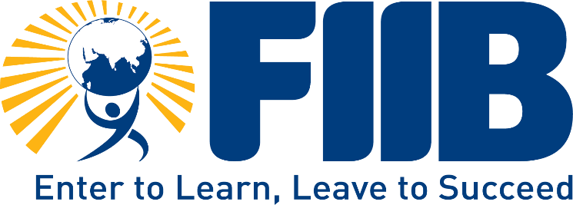



**Team Project Report – Udayan Care**

**Submitted By –**

| **S. No.** | **Section** | **Page Number** |
| --- | --- | --- |
| **1** | **Acknowledgment** | **Page 3** |
| **2** | **Certificate Of Guidance** | **Page 4** |
| **3** | **Declaration** | **Page 5** |
| **4** | **About Quality Education for Vulnerable Children** | **Page 6** |
| **5** | **About Udayan Care** | **Page 8** |
| **6** | **About Udayan Ghar** | **Page 9** |
| **7** | **List Of SDG’S of Udayan Ghar** | **Page 12** |
| **8** | **Works and Daily Activities** | **Page 15** |
| **9** | **Our Two Week Experience** | **Page 16** |
| **10** | **Responsibilities during The Internship** | **Page 18** |
| **11** | **Suggestions** | **Page 20** |
| **12** | **Learnings Experience at the NGO Home** | **Page 22** |
| **13** | **Key Take Aways** | **Page 23** |
| **14** | **Conclusion** | **Page 23** |
| **15** | **Case Study: Addressing Gaps in Education and Technical Skills** | **Page 25** |
| **16** | **Case Study: Health and Activity Management Portal** | **Page 28** |
| **17** | **References** | **Page 32** |

**Acknowledgment**

The opportunity to intern at **Udayan Care** has been a remarkable experience for learning and professional development. We feel privileged to have been part of such a noble initiative. This internship has not only enriched us academically but also instilled a deeper sense of social responsibility.

We extend our heartfelt gratitude to **Lovely Chaudhary Ma’am, Naz Parveen Ma’am, and Jaina Thomas Ma’am** for their invaluable guidance and unwavering support throughout the internship. Their mentorship, patience, and dedication ensured that we remained on the right path and made meaningful contributions to the organization. Their encouragement and insights have been a source of constant motivation.

We are also deeply grateful to our faculty mentor, **Prof. Shuchi Dikshit**, for giving us this invaluable opportunity to engage in experiential learning. Her guidance helped us build critical skills in social leadership, analysis, and awareness. Her moral support and constructive feedback throughout this internship boosted our confidence and enriched our experience.

Lastly, we express our sincere gratitude to all the children and staff at Udayan Care, whose warmth and cooperation made this journey so rewarding. This experience would not have been possible without the collective support of everyone involved.

Thank you all for your encouragement and guidance, which will continue to inspire us in our personal and professional lives.

# CERTIFICATE OF GUIDANCE

This is to certify that the project titled “Social Internship Program” is an academic work undertaken by our team and submitted in partial fulfillment of the requirements for the award of the degree of “Postgraduate Diploma in Management” from FIIB, New Delhi, under my guidance and supervision.

To the best of my knowledge, my team’s data and information presented in the project have not been submitted previously elsewhere.

**Name of the Guide – Prof. Shuchi Dikshit  
Designation – Professor at FIIB**

# DECLARATION

We take immense pleasure in expressing our heartfelt gratitude to our esteemed institution, **Fortune Institute of International Business (FIIB), New Delhi**, for providing us with the opportunity to undertake and complete this project. This report has been prepared under the guidance and supervision of our respected faculty mentor, **Prof. Shuchi Dikshit**, whose insights and support have been invaluable throughout this journey.

We extend our sincere thanks to our mentor for their constant encouragement and constructive feedback, which has guided us in making this project meaningful and impactful. Any limitations or constraints in the report are solely ours, and we take full responsibility for the same.

We have dedicated our utmost efforts and commitment to making this report informative and valuable. It has been a rewarding experience, and we hope the content reflects the effort and sincerity invested.

**1. Quality Education for Orphans and Vulnerable Children**

Quality education is a cornerstone for personal and societal growth. It equips individuals with knowledge, skills, and values necessary to navigate life, build careers, and contribute to society. For orphans and vulnerable children, access to quality education can be a transformative tool to break the cycles of poverty, dependency, and social marginalization.

Despite its importance, these children face unique challenges in accessing education. Many lack familial support, face emotional and social barriers, or live in under-resourced environments. The role of NGOs like Udayan Care in New Delhi and government agencies such as the Child Welfare Committees (CWC) of India is crucial in bridging this gap. They provide essential support, resources, and safe environments to ensure these children receive the education they deserve.

**2. What is Quality Education?**

Quality education goes beyond basic literacy and numeracy. It includes:

* **Inclusive and Equitable Education:** Ensuring that every child, regardless of background or circumstances, has access to education.
* **Trained Teachers and Resources:** Availability of skilled educators, modern teaching materials, and adequate infrastructure.
* **Holistic Development:** Focus on cognitive, social, emotional, and physical growth to prepare children for real-life challenges.
* **Accessibility:** Removing barriers to education for marginalized communities, including orphans and children in care homes.

This vision aligns with international frameworks like the United Nations Sustainable Development Goal 4 (SDG-4), which emphasizes inclusive and equitable education for all by 2030.

**3. Importance of Quality Education for Orphans**

1. **Empowerment:** Quality education provides the tools for orphans to become self-reliant and break free from cycles of dependency.
2. **Equal Opportunities:** It bridges the gap between the privileged and underprivileged, fostering social equity.
3. **Mental and Emotional Well-Being:** A structured learning environment provides stability, positive role models, and opportunities for personal growth.
4. **Career and Livelihood:** Education equips children with skills needed for employment and financial independence.
5. **Social Inclusion:** Educated children are more likely to integrate into society with confidence and dignity, breaking stigmas associated with their backgrounds

**4. Challenges Faced by Orphans and Vulnerable Children**

1. **Lack of Access:** Limited availability of quality schools in underprivileged areas creates barriers to education.
2. **Emotional and Social Barriers:** Trauma, neglect, or lack of support can affect children’s ability to focus and learn effectively.
3. **Resource Constraints:** Shortages in learning materials, digital tools, and skilled teachers hinder the learning experience.
4. **Discrimination:** Social stigma associated with being an orphan or living in a shelter home impacts children’s confidence and opportunities.

**5. Role of CWC and NGOs**

**Child Welfare Committee (CWC):**

* Ensures children are placed in safe and nurturing environments.
* Monitors educational needs and ensures compliance with children’s rights.

**Udayan Care, New Delhi:**

* Provides access to formal and informal education tailored to individual needs.
* Offers scholarships, remedial classes, and life skills training to prepare children for future challenges.
* Focuses on emotional well-being alongside academic success through counseling and mentorship programs.
* Engages in capacity-building initiatives for educators and caregivers to improve the quality of teaching.

**6. Steps to Improve Quality Education for Orphans**

1. **Teacher Training:** Equip educators with skills to address the unique needs of vulnerable children.
2. **Individualized Learning Plans:** Develop customized educational strategies for children from diverse backgrounds.
3. **Enhanced Infrastructure:** Improve facilities in shelter homes and schools to create conducive learning environments.
4. **Collaborations:** Foster partnerships between government bodies, NGOs, and private sectors for resources and funding.

Quality education is not just a right but a necessity for orphans and vulnerable children to lead dignified and fulfilling lives. NGOs like Udayan Care and institutions like CWC India play pivotal roles in transforming the lives of these children by providing them with opportunities to learn, grow, and thrive. It is the collective responsibility of society to ensure that no child is left behind, and that every child, regardless of their circumstances, has access to quality education.

**2. About Udayan Care**

Pained by the stark reality of 31 million orphans in India and shocked by the condition of institutions housing them, a few like-minded people came together to take serious action to help orphans. This obsession was the seed which sprouted as Udayan Care. Udayan Care was registered in 1994, as a Public Charitable Trust.

Udayan is a Sanskrit word, which means 'Eternal Sunrise'. The main objective of Udayan Care is to bring sunshine into the lives of underserved sections of society that require intervention. Udayan Care works relentlessly to empower vulnerable children, women and youth, in 28 cities across 15 states of India.

Udayan Care started as an establishment of just one small family home (Ghar) for orphaned and abandoned children in Sant Nagar, Delhi in 1996. But, over the years, Udayan Care has spread its work for disadvantaged groups during the last 26 years by establishing more family homes, helping girls' education, providing vocational training etc.

Till date, Udayan Care has nurtured more than 25,000 young minds. This has become possible through the support of like-minded people, donors and partners who believed in Udayan Care's work and mission.

1. **Vision and Mission**:
   * **Vision**: Transform lives through family strengthening and empowering vulnerable children, youth, and women.

***“Making Your Lives Shine”* Independence, Dignity and Opportunity for the disadvantaged of India and around the world.**

* + **Mission**: Provide nurturing spaces for at-risk children and youth, empower girls through education, and offer vocational and digital training to underserved communities, enabling them to lead dignified lives.

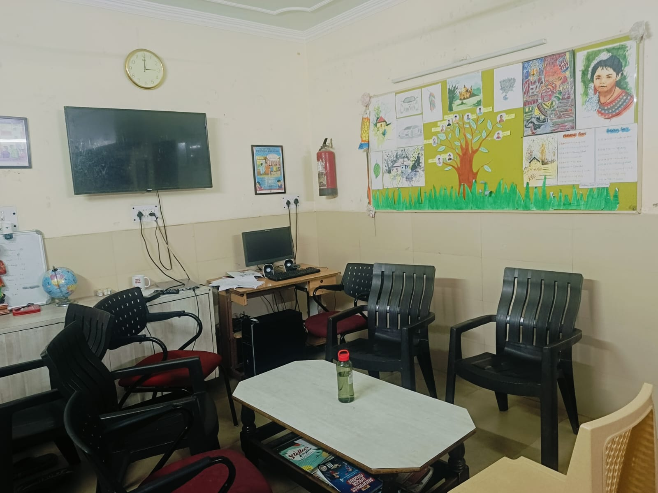

* 1. **UDAYAN GHARS**

"Udayan Ghars” is one of the major projects under the UDAYAN CARE.

The "Udayan Ghar Programme" derived from the "Sunshine Homes" idea is a special group home model based on the "L.I.F.E." core definition, an acronym for "Living In Family Environment."

N.G.O. has 17 Ghars in Delhi, N.C.R.These Ghars aim to nurture children in need of security from Out-of-Home Care (O.H.C.), including children once parentless, neglected, or abused.

The program focuses on providing children with good education, healthy food, excellent physical and mental health, and plenty of development opportunities.

A dedicated team of caregivers composed of "Mentor Parents" who are lifetime volunteers, social workers, and other professionals in child or mental health services works together to provide the love, security, and encouragement that children need to thrive.

N.G.O. has put such homes in middle-class communities, which encourages a lot of involvement and engagement in the group. As they turn into active and responsible members of society, Udayan children flourish.

* **UDAYAN GHAR'S AFTERCARE PROGRAMME**

Disadvantaged young people need continued schooling, training, therapy, mentoring, and encouragement beyond the 18 years required by the Juvenile Justice Act in a children’s home to understand their potential and succeed.

These young people, at 18, are not adequately prepared to manage life on their own and need a helping hand.

* **VARIOUS PROJECTS/ PROGRAMS UNDER UDAYAN CARE**

**UDAYAN SHALINI FELLOWSHIP PROGRAM**

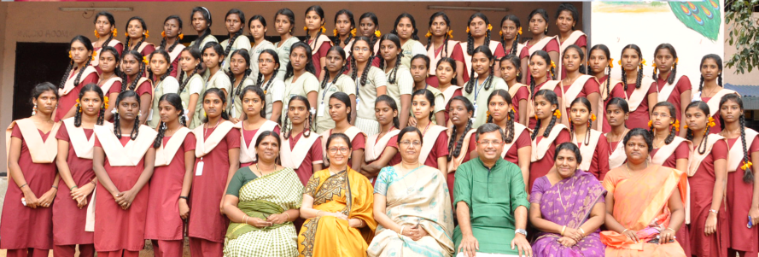

This is Udayan Care's flagship program and is a special program of academic excellence and personality growth for girls from an insufficient socio-economic context who are worthy and talented. It is intended to transform them into women or Shalinis, motivated and dignified.

Every Fellow will remain in the program until the course is finished, which is an average duration of 5-6 years.

Therefore, a Shalini is a motivated and rewarding girl sponsored by the U.S.F., who overcomes the odds of financial and social constraints by showing zeal, determination, and a mindset that never gives up.

In Indian culture, caste, poverty, and disparities are profoundly ingrained. Therefore, girls, often from economically disadvantaged families, frequently get short-changed when it comes to education. Udayan Care is remedying this disparity with the U.S.F. The N.G.O. agrees that a lack of encouragement should not limit a girl with a will to learn. U.S.F., which provides much more than financial assistance, sparked this idea. This involves mentoring, capacity-building, and seminars.

**Child and Youth Care**

* **Udayan Ghar Program**: Provides a family-like environment for orphaned and abandoned children using the LIFE (Living in Family Environment) model.
  + Operates 13 homes (Ghar) across India, housing vulnerable children and offering them education, healthcare, and emotional support.
  + Focuses on nurturing children in a stable and caring environment.
* **Aftercare Program**: Supports care leavers by preparing them for independent living, offering vocational training, financial literacy, and mentorship.

**Education**

* **Udayan Shalini Fellowship (USF)**:
  + Aims to empower underprivileged girls through education, leadership training, and mentorship.
  + Over 6,000 girls have benefited from this program, which addresses challenges faced by young women in accessing higher education.
* **School Enrollment Drives**: Ensures children in care homes have access to formal schooling and remedial classes.

**Skill Development**

* **Digital Literacy and Vocational Training**:
  + Focuses on equipping underserved youth and women with technical and soft skills.
  + More than 3,500 youth were trained this year in digital and vocational skills to enhance employability.
* Programs include:
  + Advanced computer training.
  + Workshops on career readiness and job placement assistance.

**Advocacy, Research, and Training**

* Engages in policy advocacy for alternative care and child rights.
* Published research and conducted training programs to build capacity among stakeholders in child care and protection.
* Runs the academic journal *Institutionalised Children: Explorations and Beyond* to influence care policies globally.

**Volunteer Management Program**

* Udayan Care actively involves volunteers in various roles:
  + Mentorship programs for children and youth.
  + Educational support like tutoring and organizing workshops.
  + Fundraising and administrative tasks.
* Volunteers play a key role in providing a personalized and holistic development approach.
* **Pragnya Fellowship**

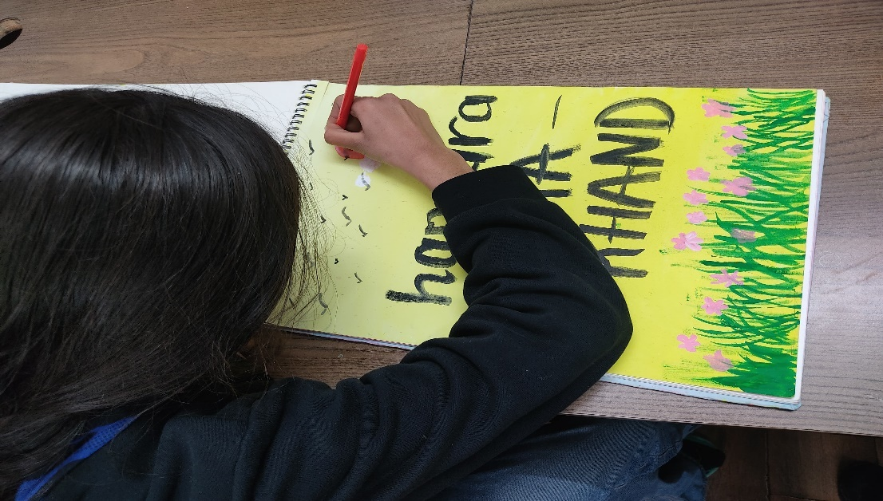

The Pragnya Fellowship is a program under Udayan Care aimed at:

* **Empowering Vulnerable Youth**: Provides holistic support to youth transitioning out of institutional care systems.
* **Support Areas**:
  + **Higher Education**: Enables fellows to pursue higher studies and vocational training.
  + **Life Skills Development**: Focuses on soft skills, career readiness, and personality building.
  + **Financial Assistance**: Offers scholarships to cover education and essential needs.
* **Mentorship**: Fellows are guided by experienced mentors to help them navigate challenges in education, employment, and independent living.

**4. LIST OF UNSDG’S ADOPTED BY UDAYAN CARE**

In order to assist disadvantaged women, children, and young people throughout India, Udayan Care, an NGO with headquarters in Delhi, coordinates its activities with a number of UN Sustainable Development Goals (SDGs). The main SDGs they emphasize are as follows:

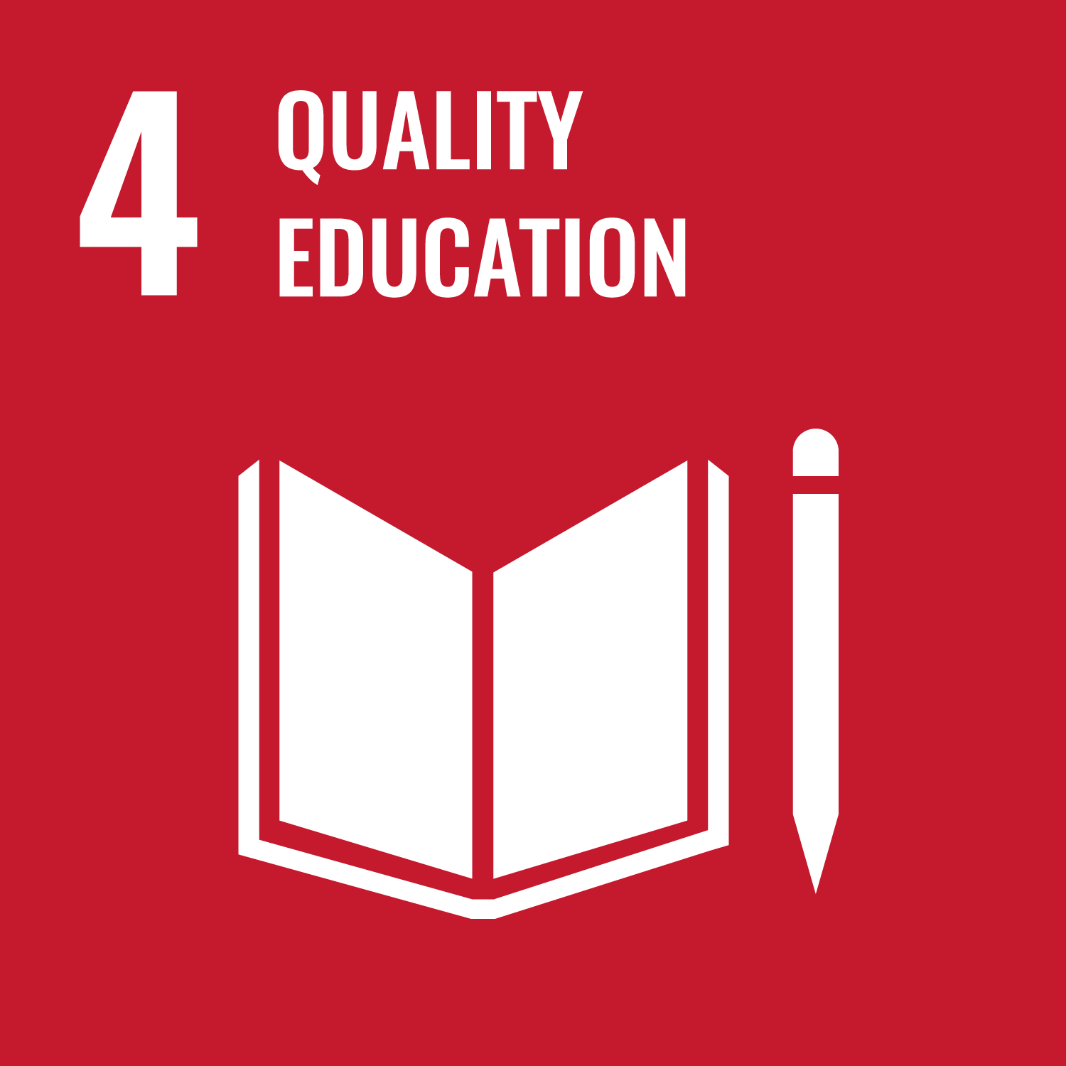

**SDG 4: Quality Education**

Udayan Care is committed to providing underprivileged women, children, and youth with inclusive, equitable, and high-quality education. Their initiatives seek to address the educational gap for underserved populations:  
  
The goal of the Udayan Shalini Fellowship (USF) Program is to give girls from low-income families access to higher education possibilities. To empower young women, it offers training on personality development, financial support, and mentorship.  
  
More than 13,000 girls have received assistance to continue their studies.  
Workshops for skill development, career guidance, and leadership training are all part of the curriculum.  
Vocational Training Centers and Information Technology (IT):  
To improve young people's computer literacy and technical skills, Udayan Care operates IT centers in multiple cities.  
  
Over 21,000 young people have received IT and employability skills training.  
Courses cover digital literacy, graphic design, programming, and English communication.

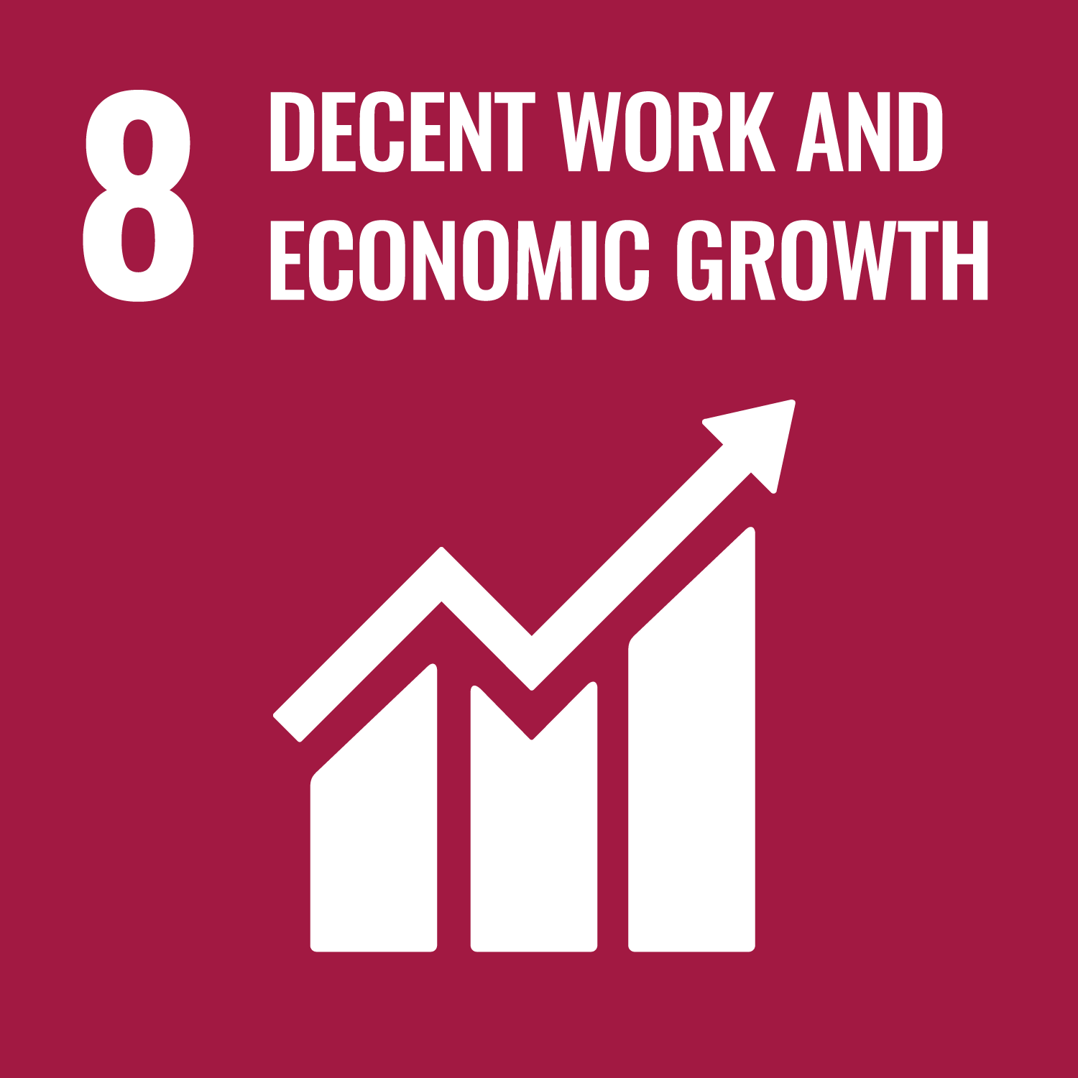

**SDG 8: Decent Work and Economic Growth**

By giving women and youth the tools they need to increase their employability and standard of living, Udayan Care promotes economic growth.

Skill Development Centers: The company provides courses in IT, beauty therapy, and tailoring, among other vocational training programs that emphasize improving practical abilities.  
Recipients receive assistance in launching their own businesses or are put in touch with possible employers.  
**Programs for Enhancing Employability:**Workshops are held on workplace manners, résumé writing, and interview techniques.  
Beneficiaries get access to real-world exposure and placement opportunities through partnerships with corporations and sectors.

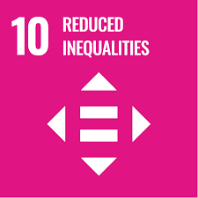

**SDG 10: Reduced Inequalities**

* By helping the most vulnerable members of society, such as women, youth, and orphaned and abandoned children, Udayan Care actively seeks to lessen inequality.  
    
  **Homes for Orphaned Children, or Udayan Ghars**  
    
  Udayan Ghars offers care, education, and emotional support to orphaned and abandoned children in homes that resemble families.  
  Since its beginning, this program has fostered almost 1,500 children.
* **Policy and Advocacy Work:**In accordance with the United Nations Convention on the Rights of the Child (UNCRC), Udayan Care promotes child rights and protection laws.  
  Programs for training stakeholders and caregivers guarantee children's overall development.
* **Scholarships and Assistance Initiatives:**  
    
  In order to lower barriers to education and economic involvement, the organization offers financial assistance and scholarships to children and youth from underserved communities.

Through these initiatives, Udayan Care contributes significantly to the development of social inclusion, decent employment opportunities, and equitable education for marginalized groups.

1. **Our Works and Daily Activities At Udayan Ghar**

|  |  |  |
| --- | --- | --- |
| Date | Activity | Outcome |
| 2nd Jan 2025 | Orientation and project allocation | Know our project and Udayan care |
| 3rd Jan 2025 | Work is given in different ghars | Understanding allocation of tasks and responsibilities |
| 4th Jan 2025 | Teach children and do some official work | Experience in teaching and understanding administrative tasks |
| 6th Jan 2025 | Fill application forms of different children and teach | Understanding application processes and gaining teaching experience |
| 7th Jan 2025 | Engage students through games and sports | Building rapport and enhancing student engagement |
| 9th Jan 2025 | Do administrative tasks like arranging documents of different students in the office and then teach children. / Maintaining Health Cards | Gaining organizational skills and teaching experience |
| 10th Jan 2025 | Do corrections in Aadhaar and PAN cards of children who need corrections and teach children | Gaining experience in handling official document corrections and teaching |
| 11th Jan 2025 | Give the Presentation on the Bad Impact of Internet on Children/ Work in Excel to make quarterly reports of different students. | Developing skills in data management and report preparation |
| 13th Jan 2025 | Work in Word to make yearly reports for every student | Building report writing and document management skills |
| 14th Jan 2025 | Fill Up the children’s ICP form-7 of Children/ Take photos of every student and add them to their respective documents | Enhancing documentation completeness and visual representation |
| 15th Jan 2025 | Teach students and do some official work | Balancing teaching and administrative responsibilities |

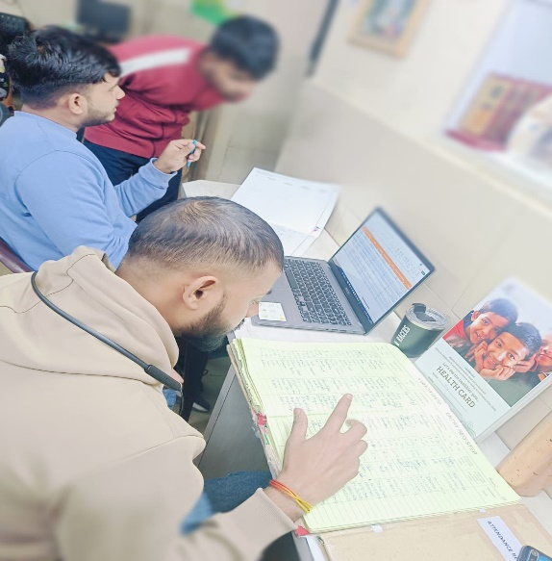 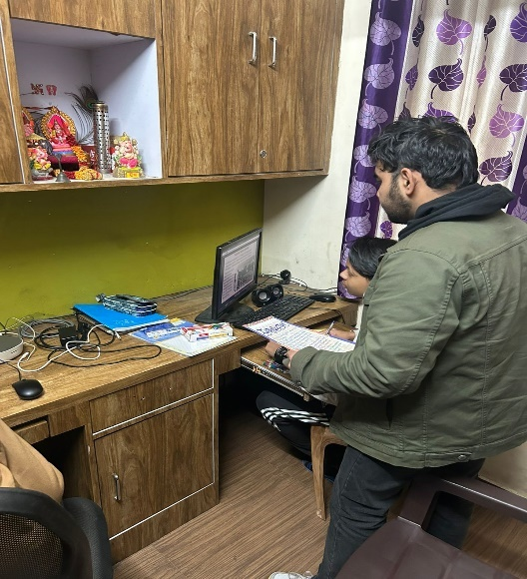

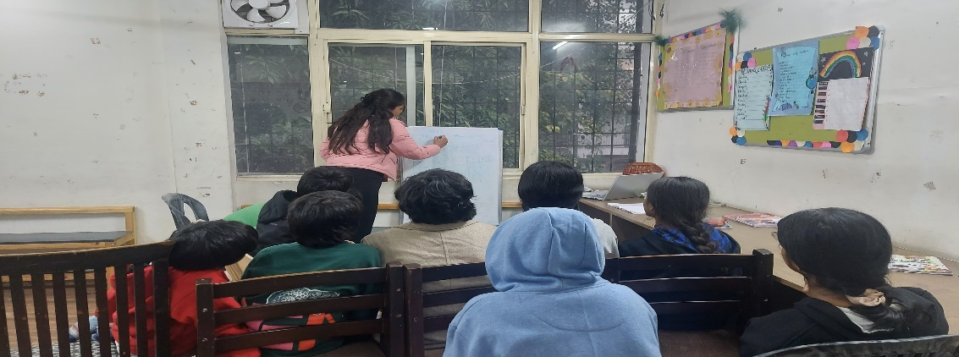

1. **Two Week Experience at the NGO Home:**

During my two-week tenure at the NGO home for adopted children, I had the opportunity to contribute to their well-being and development. The experience was both fulfilling and enlightening, allowing me to engage in various responsibilities and learn valuable lessons. Below is a detailed account of my experience:

* Engaging with the Children:
  + Built a rapport with the children through daily interactions and playful activities.
  + Ensured their emotional well-being by creating a supportive and caring environment.
  + Learned to manage diverse personalities and address their individual needs.
* Academic Support:
  + Assisted the children with their studies, helping them understand concepts, complete assignments, and stay motivated.
  + Encouraged discipline and focus in their academic approach while fostering a love for learning.
  + Identified specific areas where individual children needed extra help and provided targeted guidance.
* Documentation and Administrative Work:
  + Took part in updating important documents such as Date of Birth (DOB) certificates, PAN cards, and other necessary records.
  + Ensured the accuracy and timely completion of these updates to streamline the organization’s records.
  + Learned about the importance of proper documentation in supporting the children’s legal and administrative needs.
* Recreational Activities:
  + Organized and participated in recreational activities to create a joyful and relaxed atmosphere for the children.
  + Played games and engaged in creative activities that helped the children develop social skills and teamwork.
* Caring for Their Well-Being:
  + Ensured the children were well-cared for in their daily routines, including meals, hygiene, and emotional support.
  + Addressed their concerns and provided reassurance when they felt overwhelmed or emotional.
  + Helped create a nurturing environment where they felt safe and valued.
* Insights and Observations:
  + Witnessed the challenges these children face in their lives without parental guidance.
  + Observed their strong sense of community and the way they support each other like a family.
  + Learned about their resilience and adaptability despite their circumstances, which was truly inspiring.
* Personal Growth and Development:
  + The experience taught me the importance of empathy, patience, and kindness.
  + It reinforced the significance of providing care and support to those in need, even in small ways.
  + Developed organizational skills through handling documentation tasks and managing responsibilities effectively.

In conclusion, my two weeks at the NGO home were immensely rewarding, offering me the chance to contribute meaningfully while learning from the children’s strength and positivity. This experience left a lasting impact on me, deepening my understanding of the importance of compassion and the role we can play in improving the lives of others.

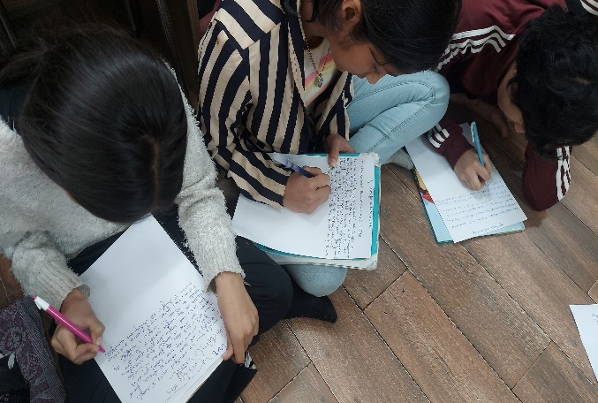 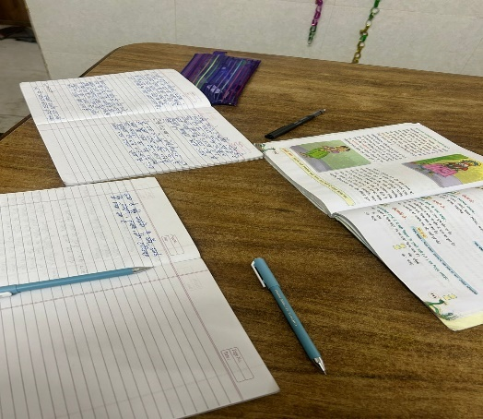

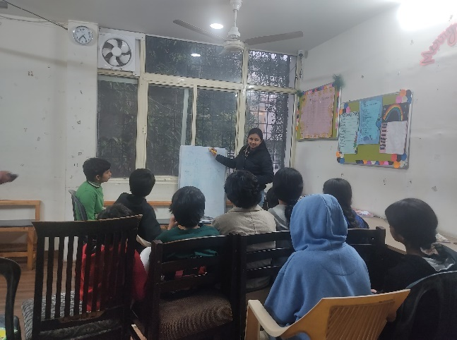 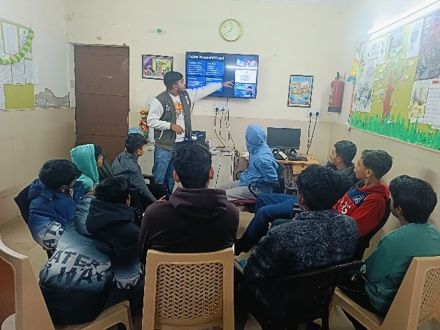

1. **Responsibilities Undertaken During the Internship**

During the 15-day internship at Udayan Care NGO, the following responsibilities were undertaken, each guided by a specific plan to ensure meaningful contributions:

1. Teaching Through Fun Activities:
   * Conducted interactive sessions like Pictionary, word searches, balloon games, and storytelling to make learning enjoyable and impactful.
   * Plan: The goal was to enhance the children’s creativity, communication, and teamwork skills through engaging, activity-based learning.
2. Documentation and Administrative Tasks:
   * Assisted in updating essential records such as **PAN card details** and **date of birth (DOB) records**.
   * **Plan**: To streamline and organize documentation, ensuring accuracy and easy access for future use.
3. **Library Management**:
   * Systematically arranged books by genre and age-appropriateness, making the library more accessible.
   * **Plan**: To transform the library into a welcoming, organized space that encouraged children to explore and develop a love for reading.
4. **Building Rapport with Children**:
   * Built trust through discussions, mentoring, and engaging activities, encouraging children to open up about their challenges.
   * **Plan**: To create a supportive environment where children felt safe to express themselves and learn valuable life lessons.
5. **Skill Development Activities**:
   * Organized role-playing and group discussions to teach life skills such as teamwork, communication, and problem-solving.
   * **Plan**: To equip children with practical skills that would empower them to handle real-life situations effectively.

Each responsibility was executed with a clear vision to address the needs of the children and contribute positively to the organization’s objectives.

1. **Challenges Faced During the Internship**

The 15-day internship at Udayan Care NGO came with several challenges that required thoughtful approaches and adaptability. These challenges included:

1. **Understanding the Diverse Needs of Children**:
   * The children came from various socio-economic and emotional backgrounds, making it necessary to tailor teaching methods and activities to accommodate their different learning capacities and interests.
   * Special children required individualized attention, patience, and strategies to address their unique needs effectively.
2. **Building Trust and Engagement**:
   * Establishing a connection with the children took time, as some were initially hesitant or reserved. Creating a safe and engaging environment required consistent effort and creative approaches.
   * Fun icebreaker activities such as **balloon games** and storytelling helped create a comfortable and interactive environment. These activities encouraged the children to open up and participate actively, fostering a sense of belonging.
3. **Managing Behavioral Challenges**:
   * Behavioral issues, such as restlessness or defiance, occasionally disrupted sessions. Addressing these behaviors while maintaining a positive and inclusive atmosphere was a delicate balance.
   * To manage this, interactive activities such as **group challenges** and **team-based word-building games** were introduced, which channeled their energy positively and promoted collaboration. Additionally, individual attention was given to children needing extra guidance.
4. **Time Constraints**:
   * The short duration of the internship limited the ability to implement long-term strategies or assess the full impact of the efforts. Balancing short-term goals with meaningful engagement was a challenge.
5. **Limited Resources**:
   * Conducting activities required materials like art supplies and teaching aids, and limited resources sometimes restricted the scope and variety of planned sessions.
6. **Emotional Challenges**:
   * Listening to the children share their struggles and life challenges created moments of emotional difficulty, requiring a balance between empathy and professionalism.
7. **Communication Barriers**:
   * Interacting with children who had limited language skills or hesitated to express themselves posed challenges in ensuring effective communication.

Despite these challenges, the experience provided valuable insights into working with children from diverse backgrounds and fostered the development of important skills like adaptability, patience, and empathy.

1. **Suggestions:**
2. **Expansion of Individualized Learning Plans**:
   * Develop tailored educational strategies that address the unique needs of each child. For example, **children with learning disabilities could benefit from adaptive teaching tools like educational apps that focus on visual learning, such as Khan Academy or Quizlet.** Similarly, those with emotional barriers might need one-on-one mentoring to build confidence and overcome anxiety in classroom settings.
3. **Strengthening Teacher Training**:
   * Equip educators with specialized skills to handle the unique psychological, social, and academic challenges faced by vulnerable children. For instance, **teachers could be trained in trauma-informed teaching methods, enabling them to recognize signs of distress and create a supportive learning environment.** Additionally, workshops on inclusive teaching practices can help educators address the needs of children with diverse learning styles.
4. **Enhanced Aftercare Programs**:
   * Extend support to young adults leaving institutional care by providing mentorship, financial literacy training, and housing assistance. For example, **an aftercare program could include partnerships with local businesses to offer internships or apprenticeships to care leavers, such as providing on-the-job training in fields like retail, IT, or hospitality.** This ensures a smoother transition into independent living.
5. **Digital and Vocational Literacy**:
   * Expand IT and vocational training initiatives to align with industry demands and increase employability. For instance, **introducing courses in emerging fields such as digital marketing, coding, and AI could prepare underserved youth for high-demand job markets.** In addition, vocational training in areas like tailoring, beauty therapy, or graphic design can help individuals establish their businesses or secure employment.
6. **Community Engagement Initiatives**:
   * Foster stronger connections with local communities to create a broader support network for children. For example, **organizing “open house” events in Udayan Ghars where local residents can volunteer, mentor, or participate in cultural activities with the children could help reduce stigma and build relationships.** Local businesses could also be encouraged to sponsor educational materials or extracurricular activities.
7. **Monitoring and Evaluation**:
   * Implement systems to regularly assess the effectiveness of educational and development programs. For example, **using feedback tools such as surveys, progress reports, and focus group discussions with children and staff could help identify strengths and areas for improvement.** This data could then be used to refine teaching methodologies and program strategies.
8. **Resource Mobilization**:
   * Strengthen partnerships with corporates, government bodies, and philanthropic organizations to ensure sustainable funding. For instance, **a partnership with companies under their Corporate Social Responsibility (CSR) initiatives could provide resources like computers, books, or infrastructure upgrades.** Collaborations with international donors can also help fund large-scale projects like establishing new learning centres.
9. **Promotion of Emotional Well-being**:
   * Prioritize mental health by increasing access to counselling and mentorship. For example, **introducing regular group therapy sessions facilitated by trained counsellors could help children process their emotions and develop coping mechanisms.** Additionally, peer mentorship programs where older children guide younger ones can foster mutual support and leadership skills.

By implementing these suggestions, supported with practical examples, Udayan Care and similar organizations can further strengthen their efforts in empowering vulnerable children and youth, ensuring long-term impact and sustainability.

1. **Learning Experience at the NGO Home**

During my time at the NGO home for adopted children, I gained several important insights and life lessons. Below are the key aspects of my learning:

* **Challenges of Living Without Parents:**
  + I observed how difficult life is for these children without parental guidance and emotional support.
  + They often struggle with tasks and decisions that would typically be made easier with a parent's presence.
* **Emotional Resilience:**
  + Despite their hardships, the children display incredible strength and resilience in adapting to their circumstances.
  + Their ability to smile, play, and stay optimistic in the face of adversity is inspiring.
* **Everyday Struggles:**
  + Even simple tasks, such as managing studies, building confidence, and dealing with personal issues, are more challenging for them.
  + The lack of a consistent support system often forces them to mature faster than other children.
* **Sense of Community:**
  + The children form close bonds with one another, creating a family-like atmosphere within the NGO.
  + They support and care for each other, showing how essential companionship is in their lives.
* **Moments of Vulnerability:**
  + While the children often display strength, there are moments when their longing for parental love becomes evident.
  + Seeing them get emotional was heart-wrenching, but it also highlighted the importance of providing emotional stability and care.
* **Value of Support Systems:**
  + My experience underscored the crucial role that NGOs and volunteers play in supporting these children’s physical, emotional, and educational needs.
  + Even small acts of kindness and understanding can have a significant positive impact on their lives.

This experience gave me a deeper appreciation for the strength of the human spirit and the importance of compassion. It taught me the value of emotional support, patience, and the need to create opportunities for these children to thrive.

1. **Key Takeaways**

* **The Power of Education and Emotional Support in Changing Lives**: This experience highlighted how education and emotional care can completely transform the lives of vulnerable children. It’s not just about teaching them facts or figures—it’s about giving them the tools and confidence to dream, grow, and succeed.
* **The Role of Structure in Nonprofit Management**: Working at Udayan Care made it clear that structured systems are crucial for running a nonprofit effectively. Whether it was maintaining accurate records, planning activities, or organizing resources, I learned how having an organized approach can make a big difference in achieving long-term goals for the community.
* **Understanding the Challenges Faced by Vulnerable Communities**: Interacting with these children opened my eyes to the daily struggles they face, from financial difficulties to emotional trauma. It was a humbling experience to understand their resilience and to see how small gestures of support could help them overcome significant hurdles.
* **Developing Skills to Contribute to Social Causes**: This internship helped me grow both intellectually and emotionally. I gained practical skills like documentation and task management, but more importantly, I learned to connect with people on a deeper level. It showed me how empathy and dedication can create meaningful impacts and prepared me to contribute to similar causes in the future.

1. **Conclusion**

Our internship at Udayan Care has been an incredibly rewarding and eye-opening journey. It gave us the chance to not only contribute to the lives of children in need but also grow as individuals. We were able to directly see how education, emotional support, and a structured approach to care can change lives for the better. This experience taught us that even small efforts can make a significant impact when done with compassion and intention.

Spending time with the children, understanding their stories, and being part of their growth was both heartwarming and humbling. We saw their resilience and learned how much of a difference proper guidance, encouragement, and resources can make in helping them dream of a better future. It was inspiring to witness the dedication of Udayan Care in nurturing these children, not just academically but also emotionally and socially.

On a personal level, this internship helped us develop empathy, patience, and a deeper understanding of the challenges faced by vulnerable communities. It also taught us the importance of teamwork, organization, and effective communication when working in the nonprofit sector. These lessons will stay with us and guide us in both our professional and personal lives.

We are truly grateful for the opportunity to contribute to Udayan Care’s mission. This experience has deepened our commitment to supporting initiatives that aim to create meaningful change in society. We leave this journey with a sense of fulfillment and a renewed passion for making a positive difference in the world.

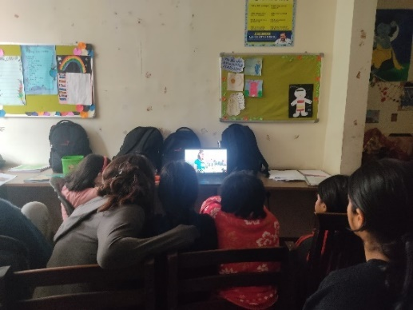 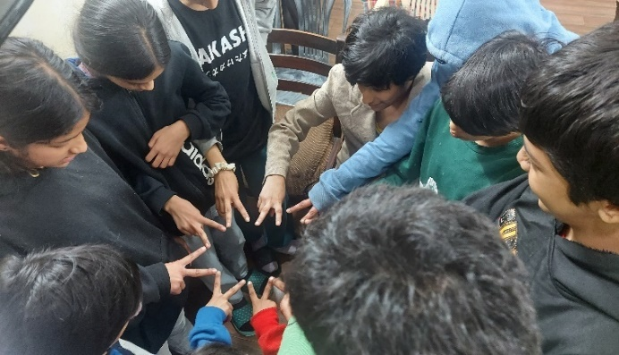

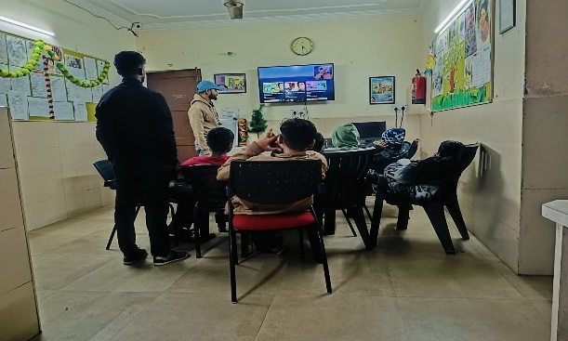 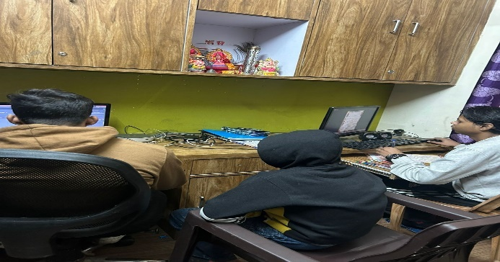

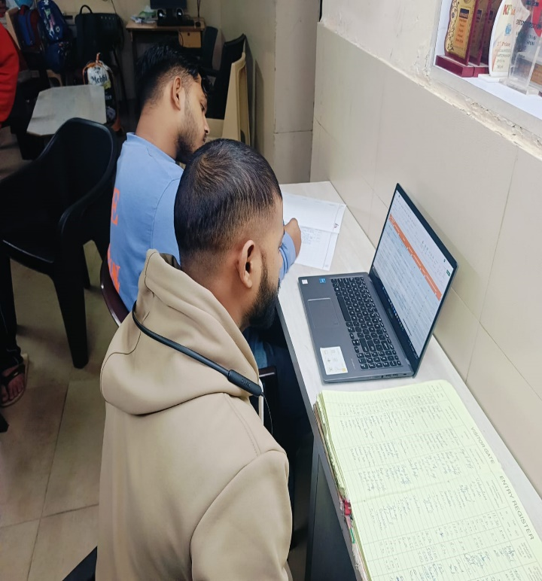 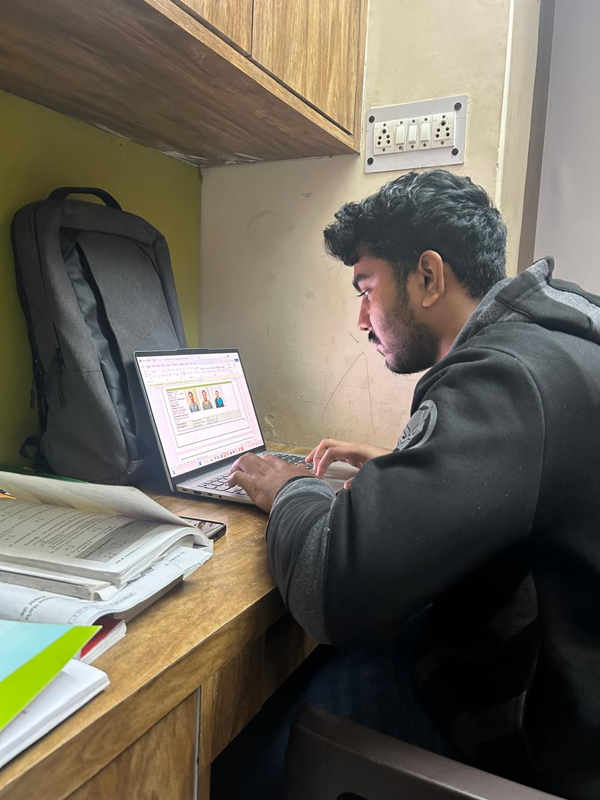

1. **Case Study: Addressing the Gaps in Quality Education and Technical Skills at Udayan Care**

**Problem Statement**

While Udayan Care excels in providing basic education and vocational training, there is a significant gap in imparting **technical and digital literacy**. The following challenges were identified:

1. **Lack of Advanced Educational Resources**:
   * Limited exposure to modern tools like Microsoft Excel, Canva, and AI-driven applications.
   * Over-reliance on traditional teaching methods, which fail to align with industry standards.
2. **Insufficient Digital Infrastructure**:
   * Lack of access to computers, high-speed internet, and licensed software in learning centers.
   * Low integration of digital learning tools in their education programs.
3. **Teacher Training Deficiency**:
   * Limited capacity-building initiatives for educators to adopt and teach modern technologies.
4. **General Skill Gap**:
   * Beneficiaries lack exposure to 21st-century skills like data analysis, online collaboration, and digital marketing.
   * Limited emphasis on creative problem-solving and critical thinking.

**Impact Analysis**

The absence of technical skills has cascading effects on the future of Udayan Care’s beneficiaries:

* **Employability**: Youth are underprepared for jobs requiring digital literacy, impacting their career prospects.
* **Economic Inclusion**: Lack of skills excludes beneficiaries from participating in the rapidly growing digital economy.
* **Educational Inequality**: Beneficiaries fall behind peers with access to modern tools, perpetuating cycles of disadvantage.

**General Data on Education and Skill Development**

1. **Global Digital Skills Gap**:
   * According to a 2023 LinkedIn survey, 75% of employers worldwide report a shortage of candidates with adequate technical skills.
   * The World Economic Forum highlights that 50% of all employees will need reskilling by 2025 due to digital transformation.
2. **India-Specific Context**:
   * A NASSCOM study (2022) revealed that 58% of India’s youth lack basic digital skills.
   * Rural youth, such as many Udayan Care beneficiaries, face a 60% higher likelihood of being digitally excluded compared to their urban counterparts.
3. **Case Comparisons**:
   * NGOs like Pratham and Teach For India have successfully integrated digital tools into their programs, resulting in a 30% improvement in students’ employability.

**Proposed Interventions**

To address these gaps, Udayan Care can adopt the following strategies:

1. **Digital Infrastructure Enhancement**:
   * Establish well-equipped computer labs with internet access in Udayan Ghars and skill development centers.
   * Partner with tech companies like Microsoft, Google, or local startups to provide licensed software and hardware donations.
2. **Integration of Modern Tools in Curriculum**:
   * Introduce training modules on:
     + **Microsoft Excel** for data analysis and management.
     + **Canva** for creative design and marketing.
     + **AI Tools** like ChatGPT for learning assistance.
   * Leverage platforms like Coursera and Khan Academy to provide online courses on technical skills.
3. **Teacher Capacity Building**:
   * Conduct regular workshops for teachers on modern pedagogical methods and digital tools.
   * Create a peer-to-peer learning network among educators for sharing best practices.
4. **Student-Centric Initiatives**:
   * Organize hackathons and design challenges to foster creativity and innovation.
   * Introduce career counselling sessions to align skill training with market demands.
5. **Monitoring and Evaluation**:
   * Implement a robust system to track the progress of students’ technical skills and employability outcomes.

**Expected Outcomes**

If implemented, the above strategies can lead to:

1. **Improved Employability**: Beneficiaries gain in-demand skills, enhancing job prospects.
2. **Economic Empowerment**: Increased earning potential through participation in the digital economy.
3. **Educational Equity**: Beneficiaries achieve parity with peers exposed to advanced technologies.
4. **Organizational Growth**: Udayan Care strengthens its reputation as a forward-thinking NGO.

**Conclusion**

Udayan Care has made commendable strides in supporting vulnerable populations, but evolving with the times is crucial. By addressing the gaps in quality education and technical skills, the organization can further its mission of empowering children and youth. Investing in digital literacy, teacher training, and modern infrastructure will not only enhance individual outcomes but also contribute to a more equitable and skilled society.This case study underscores the importance of bridging the skill gap at Udayan Care, ensuring that beneficiaries are prepared to navigate and succeed in an increasingly digital world.

1. **Case Study: Developing a Secure Child Health and Activity Management Portal for Udayan Care**

**Problem Statement**

Managing the vast and varied information of children across multiple homes (Udayan Ghars) and programs remains challenging. Key challenges include:

1. **Lack of Centralized Records**:
   * No system exists to maintain health metrics like BMI, weight, height, or medical histories.
   * Records of dental, eye, and general health check-ups are scattered and often inaccessible for timely decisions.
2. **Limited Visibility into Legal and Developmental Progress**:
   * Information about CWC hearings, placement dates, and educational milestones is fragmented.
   * Activity logs, including extracurricular participation and school attendance, are not systematically recorded.
3. **Risk of Data Mismanagement**:
   * Critical information is vulnerable to errors and loss without a centralized repository.
   * Current manual processes pose risks to confidentiality and security.
4. **Missed Opportunities for Analytics**:
   * Lack of data prevents analysis for health trends, educational gaps, and timely interventions.

**Proposed Solution: Child Health and Activity Management Portal**

A **Child Health and Activity Management Portal** is proposed to address these challenges. This secure, centralized platform will digitally record and manage all critical child-related information.

**Key Features:**

1. **Unique ID Generation:**
   * Each child is assigned a unique identifier upon registration in the portal. This ID ensures accurate tracking across all activities and records.
2. **Health Management Module:**
   * Comprehensive health profiles for every child, including:
     + Basic health metrics: BMI, weight, height.
     + Medical history: Records of illnesses, vaccinations, allergies, and chronic conditions.
     + Routine check-ups: Logs of monthly or quarterly dental, eye, and general health assessments.
     + Complaint tracker: Reports of health issues raised by children.
3. **Legal Documentation Module:**
   * Tracks dates and outcomes of CWC hearings.
   * Records legal history, including court orders and guardianship details.
   * Stores case-related documents for easy retrieval.
4. **Educational and Activity Tracker:**
   * Records school enrollments, attendance, and academic performance.
   * Logs participation in extracurricular activities, workshops, and vocational training.
5. **Access and Confidentiality Controls:**
   * Role-based access ensures that only authorized personnel (e.g., caregivers, medical staff, legal representatives) can view or update specific records.
   * Data is encrypted to maintain confidentiality and prevent breaches.
6. **Analytics Dashboard:**
   * Provides insights into health trends, attendance, and performance gaps.
   * Generates alerts for overdue check-ups or CWC hearings.

**Example Use Case**

**Case: Ravi, a 12-Year-Old in Udayan Ghar**

* **Health Management**:
  + Ravi’s portal shows a BMI of 16.5 (underweight). The dashboard flags this and recommends a dietician’s review.
  + Quarterly dental check-ups reveal recurring cavities, prompting additional fluoride treatment.
* **Legal Documentation**:
  + The portal notes Ravi’s CWC hearing scheduled for March 15, 2025, and sends reminders to the legal team.
  + Historical records show Ravi’s placement date (May 12, 2023) and previous case notes.
* **Educational Progress**:
  + Ravi’s school attendance is 88%, with improved grades in math after remedial classes were scheduled.
  + The portal logs his participation in a painting competition, boosting his confidence.

**Critical Considerations**

1. **Data Confidentiality and Security:**
   * Strict encryption protocols must protect sensitive data.
   * Role-based access ensures that only relevant personnel can view specific information.
   * Periodic audits and compliance checks are essential to prevent breaches.
2. **Scalability:**
   * The portal must handle data from multiple Udayan Ghars and scale to accommodate future expansions.
3. **Integration with Existing Systems:**
   * Seamless integration with Udayan Care’s website and other digital tools to avoid duplication of efforts.
4. **Legal Compliance:**
   * The system must adhere to Indian laws, including the Juvenile Justice Act and data protection regulations.

**General Data Supporting the Need**

1. **Digital Transformation in Child Care**:
   * A UNICEF report (2022) emphasizes the role of technology in improving child welfare, citing a 40% improvement in service delivery with digital tools.
2. **Health and Legal Management**:
   * According to WHO (2021), consistent health monitoring can reduce preventable illnesses in children by 25%.
   * Legal delays often disrupt placements; digitized records can reduce processing times by 30%.
3. **Education and Skill Development**:
   * Research by NITI Aayog (2023) highlights that integrated platforms can improve school attendance rates by 20%.

**Implementation Plan**

1. **Phase 1: Planning and Development**
   * Partner with IT developers to design and build the portal.
   * Identify key stakeholders (caregivers, medical staff, legal advisors) to define data requirements.
2. **Phase 2: Pilot Rollout**
   * Launch the portal in 2-3 Udayan Ghars as a pilot program.
   * Collect feedback from users and address challenges.
3. **Phase 3: Full Implementation**
   * Extend the portal to all Udayan Ghars and programs.
   * Provide training sessions for all staff to ensure smooth adoption.
4. **Phase 4: Monitoring and Optimization**
   * Regularly review the portal’s effectiveness and introduce updates.
   * Use analytics to refine care strategies.

**Expected Outcomes**

1. **Enhanced Care Delivery**:
   * Real-time access to health, legal, and educational data enables timely interventions.
2. **Improved Operational Efficiency**:
   * Centralized records reduce duplication and streamline processes.
3. **Data-Driven Decisions**:
   * Analytics provide actionable insights to improve child outcomes.
4. **Strengthened Accountability**:
   * Clear documentation ensures transparency and accountability.

**Conclusion**

A Child Health and Activity Management Portal is a transformative solution for Udayan Care. By digitizing records and processes, the organization can provide better care, ensure compliance, and empower children with a brighter future. The portal represents a critical investment in technology, aligning with global best practices in child welfare and ensuring that Udayan Care remains at the forefront of transformative care in India.

1. **References**

**<https://udayancare.org/udayan-ghars/udayan-ghars-children-homes?gad_source=1&gclid=Cj0KCQiA-aK8BhCDARIsAL_-H9m9msmbh-weavgAbPcTxWmcrmevS9tfPk0BYgykElLnMHtfrgWH-1IaAroBEALw_wcB>**